PERSONA: John

TOPIC: Security

1. EMPATHIZE



Extensions to the persona:

* John lives in a dangerous neighborhood, there were several break into houses lately
* John has a car and several bikes for the family which are parked in front of his house
* John has security alarms and cameras in his home and must control them
* In the neighborhood there is a WhatsApp group for controlling the streets for weird activities
* John is busy with work and is not at home, his wife also has a job and is not home a lot
* His kids are just starting with school and spend time in the streets alone sometimes
* John lives in a small town next to the city where he works, similar to where I(Gil) live in Spain. Normal neighborhood with houses and that most of the people know each other. Not all the houses have alarms and there are not a lot of high security systems

Does:

* John always puts on his alarms when he leaves home
* John parks his car always in front of his home
* John uses his car every day to go to work
* John sometimes brings his kids to school
* John has working days from 9 to 5 and often must work overtime
* John uses internet every day to work and meet new people

Feels:

* John feels afraid that someone will break into his house.
* John feels like he must be aware of everything that happens in his street
* John feels worried when his kids play in the street or when they are going to school
* John is insecure about parking the car outside
* John is afraid of losing his job and he cannot feed his family anymore
* John is afraid he will be outplayed by technology or other competitors at his job
* John is worried about his security in his own house
* John feels like he can’t leave the house without setting his alarms

Needs:

* Security for his kids
* Security for his house
* Security with networking
* Security for his internet usage
* Security for his car
* To control the alarms and cameras from wherever he is
* To know what his kids are doing and where they are
* To confirm his place in the company
* To be aware of what is happening in his street even if he is not there

Goals:

* John has the goal to feel secure again in his own neighborhood
* John wants to invest in his career and build a secure job environment for himself
* John wants to have his house and what is happening around it controlled
* John wants to be able to park his car in front of his house safely
* John has the goal that his kids can move around the neighborhood safe
* John wants to make more connections to professionals to grow in his career
* John wants to be aware of everything that’s happening in his street at every time

Persona day in the life:

John wakes up at 7 and does the breakfast for his family and helps his kids get ready for school. During that he reads the news at breakfast. He sees that there are more break ins in his neighborhood than before. It is disturbing him. When he is done, he brings his kids to school and then he goes to work. He sets the alarms of his home and goes. John goes to work now and starts working. John is still thinking about the news he read this morning. At his work he is a professional, but his job is not secure because there is a lot of competition in his working field. So, he could be replaced if he fails at his job. John must work overtime and is back home late. When he comes home, he parks his car in front of his house. He feels insecure about the parking space because of the break-ins in his neighborhood. He walks into his home and sees his kids. They are home safely. When John is home, he is looking for ways of securing his house better. When John is home he checks out the neighborhood through his window, if he sees something suspicious . After checking this he puts his kids in bed and he tries to have a relaxing evening before going to bed.

1. DEFINE

Problem Statements:

* His neighborhood is not secure
* Isn’t secure about his job position
* Does not have an overview of all his alarms in the house
* His car and bikes are in front of the house, and he can't keep an eye on them
* He can't let his kids play on the street safe
* When he leaves the house, he must set all his alarms in the house one by one
* He is alarmed every time someone sends a message in the security WhatsApp group and he doesn't see it

Point of view:

[**User** . . . (descriptive)] needs [**need** . . . (verb)] because [**insight.** . . (compelling)]

* John needs a mobile controlling security system because it can help him with setting the alarms up in his house
* John needs a way to control his kids when they are in the street because it is dangerous for them to stay alone outside
* John needs to be able to park the car and the bikes in front of his house safely because if not someone can steal them

How might we questions:

How might we, so …

* How might we help John feel safe in his neighborhood, so he can feel relaxed when he is home or outside?
* How might we help John to keep an eye on his kids when they are playing, so John doesn't have to worry about them?
* How might we help John with the safety of his car, so he does not have to keep an eye on everything and everyone all the time?
* How might we help John prevent someone breaking into his house, so he does not lose any of his possessions?

Personal experience:

Where I live in Spain it’s not a dangerous place, it is very calm and with not much activity, but maybe because of that in the last few years there have been some burglaries. Because of that we created a Whatsapp group with all the neighbors to advertise if someone was seeing something strange like an unusual car or if an alarm was ringing so that all the other neighbors could be aware of it and try to help each other. It has been useful but sometimes if you have a lot of messages from other chats you don’t see a specific message from this group that maybe is very important.

1. IDEATION

Brainstorming IT-solutions:

* An app that will track his kids where they are and the kids can give updates about what they are doing
* An app which can control the alarms of the house and can rotate cameras so you can look what is going on in your house from a distance
* An app which allows you to use cameras in the street so you can control your neighborhood
* Trackers for bikes and cars so when it gets stolen you can find it back
* **An app that all the neighbors have and they can advertise when something is happening in the neighborhood, the other people receive an alarm/notification on their phones**
* A camera outside the house that detect if something is moving
* A way to set all the alarms automatically when he leaves home

**Main Idea:**

An app that all the neighbors have and they can report when something is happening in the neighborhood, the other people receive an alarm/notification on their phones. The home screen would be a dashboard with different buttons for the different crimes or things to warn, when you click one you set the house or place that it is happening and all the neighbors receive the notification of it. Also a button to do a quick emergency call. The app doesn’t guarantee the full safety of your neighborhood but it will give you the feeling that everybody is watching the neighborhood. This should give you a safer feeling. The app is not made for daily use, just for emergency cases.

**Most common warnings in the neighborhood:**

* Strange person
* Strange car
* Alarm ringing
* Smoke/fire
* Burglary
* Violence
* Noise

**Features:**

* Emergency call
* Extremely easy and fast interface; one screen with all the reports you can make of crimes or things to warn with different colors
* Map which will show your area and the reports
* Set up an account for your location
* Make a report which appears in the home screen
* Groups for your area with people who you know
* Adding phone numbers for emergency calls
* The possibility to add photos of what is happening
* Link the app to the security cameras and alarms
* Push notifications
* Chat option

**Possible Problems:**

* False reports
* Not knowing who lives in your neighborhood
* Nobody is in the neighbor when a thing is happening
* A phone is on silence so the notification will not be heard
* Internet connection
* Not enough members to share the reports with
* No trust with your neighbors
* People who call the emergency too quick
* Lack of privacy
* A neighborhood who is watching each other too much
* People with no smartphone can't use the app
* Too many messages and notifications for nothing
* Maybe for your neighbor something is strange but for you not (you receive a visit of a friend and the neighbor thinks he/she is a strange person for example)

**Existing similar apps:**

IOS & Play store:

* Neighbors by Ring (the app is only useful in the US)
* Veiligebuurt, nieuws & preventie: Good app which allows you to become part of a group in your street. Also gives you the opportunity to report a crime. Doesn't have a function to call the emergency immediately. It has a simple interface and it is easy to use. Only for the Netherlands.

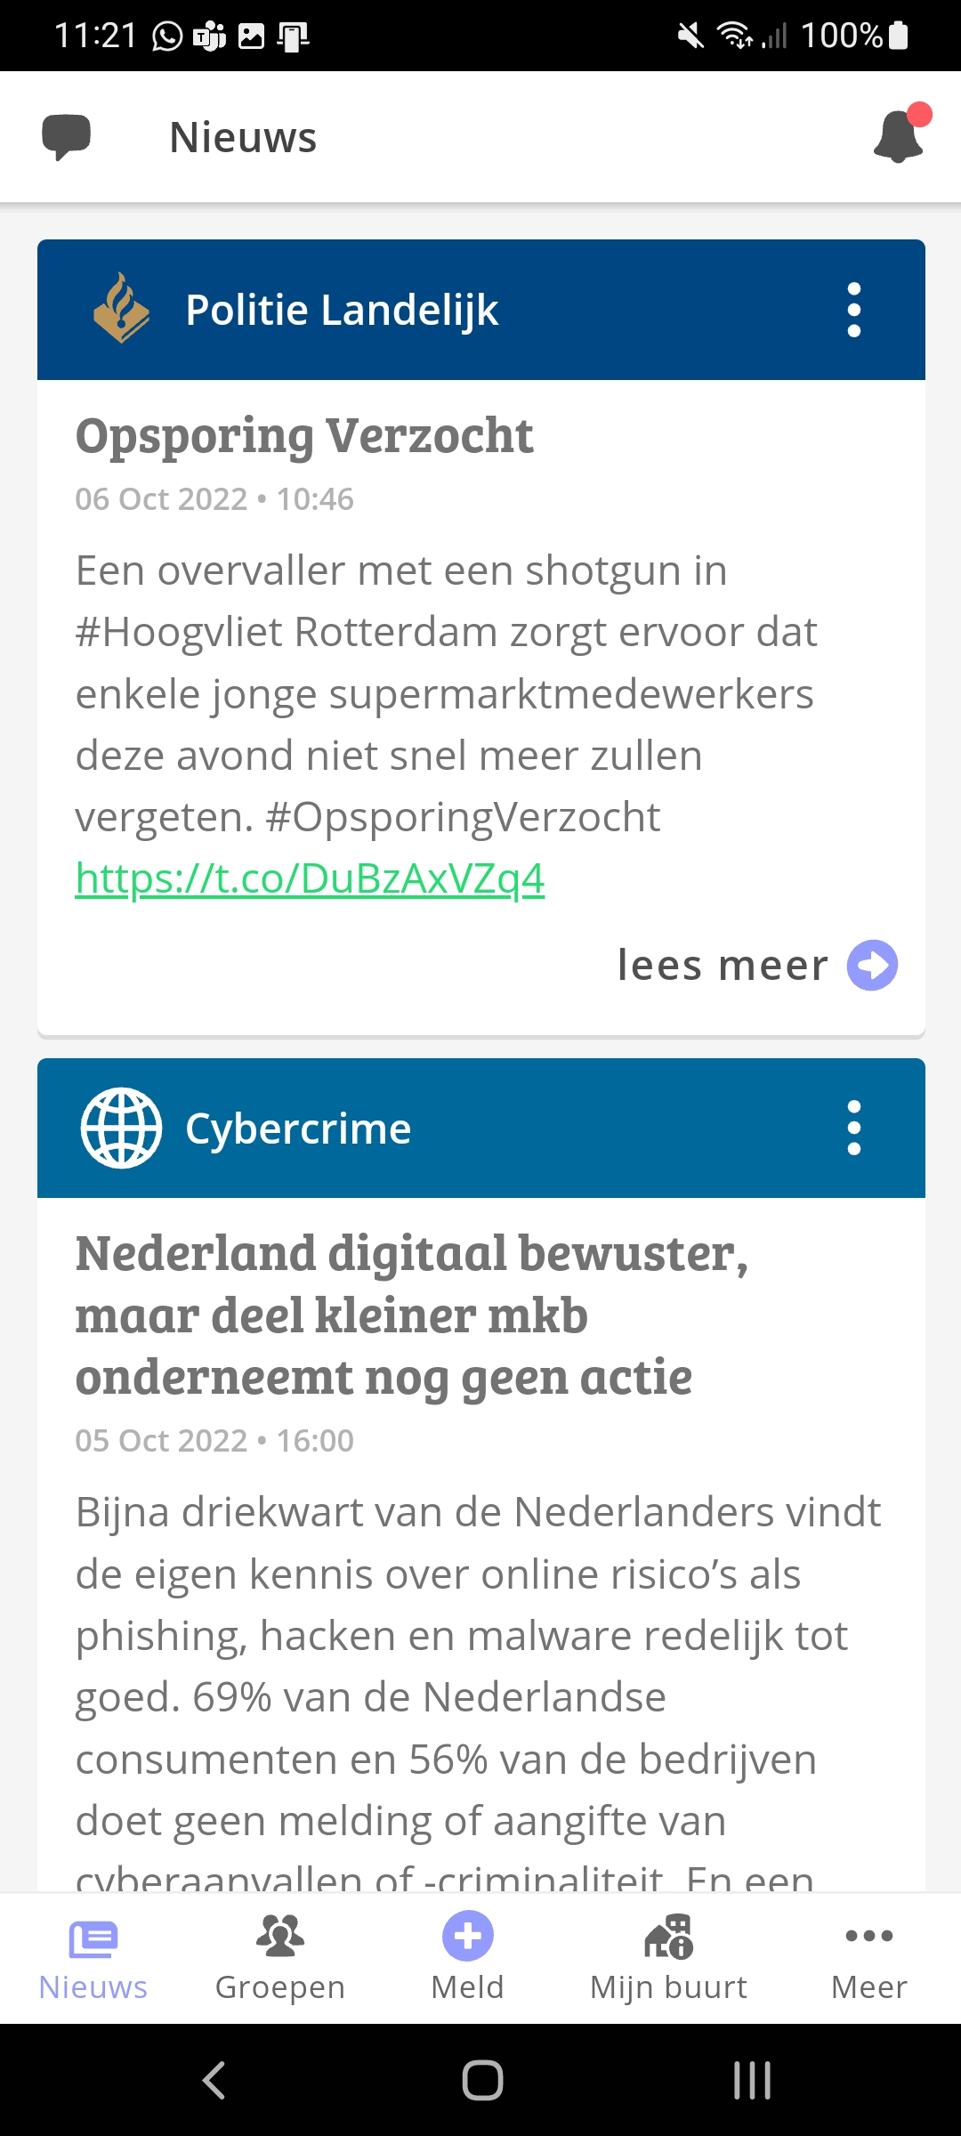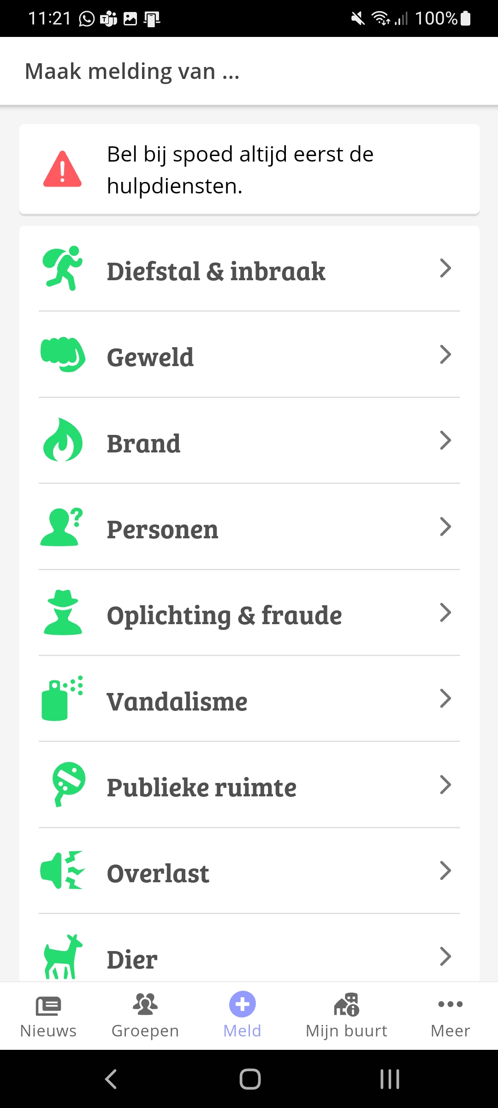

* Naber: the app seems nice but once you install it is not like the photos, has a terrible interface and it’s terrible to use.

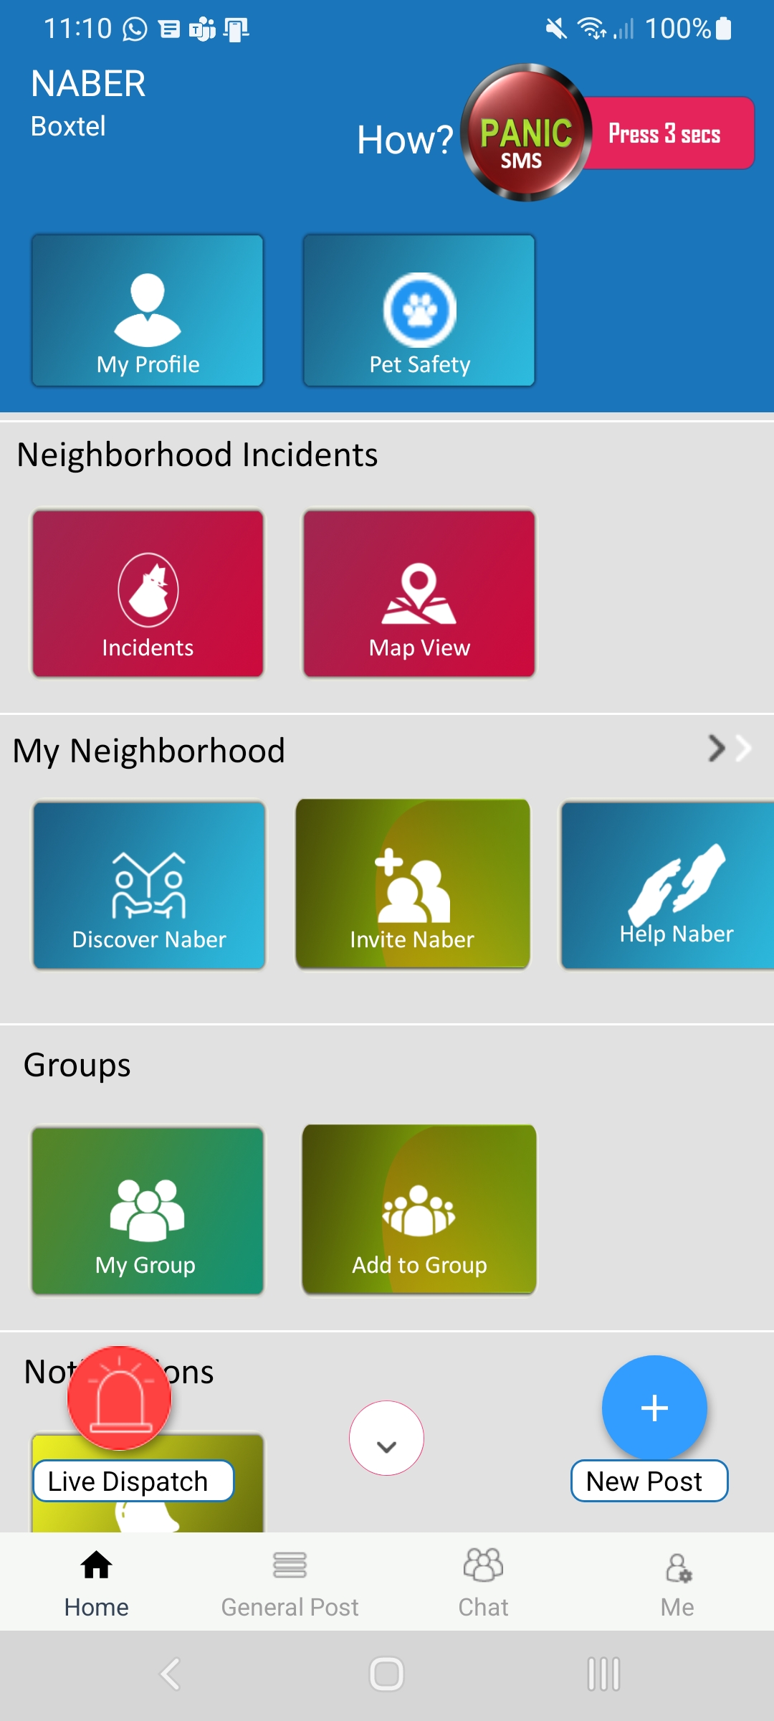

1. PROTOTYPING

Paper prototypes